Multilayer Perceptron for Images

Annie Samarpitha Chandolu

2025, Fall – Full Term, and Generative AI with Large Language Models (MSAI-630-M40)

August 31, 2025

Multilayer Perceptron for Images
In this assignment, three multilayer perceptron (MLP) models were trained on the MNIST dataset with different activation functions: Rectified Linear Unit (ReLU), LeakyReLU, and Sigmoid. The goal was to evaluate how activation functions influence convergence, accuracy, and model behavior. Activation functions are critical for deep learning because they introduce nonlinearity, enabling models to learn complex representations (Foster, 2022). The base code for this assignment was adapted from the official GitHub repository accompanying the textbook (Foster, 2022). I used this code to build and train the models and obtained the reported accuracy and loss results.

ReLU using GitHub Code
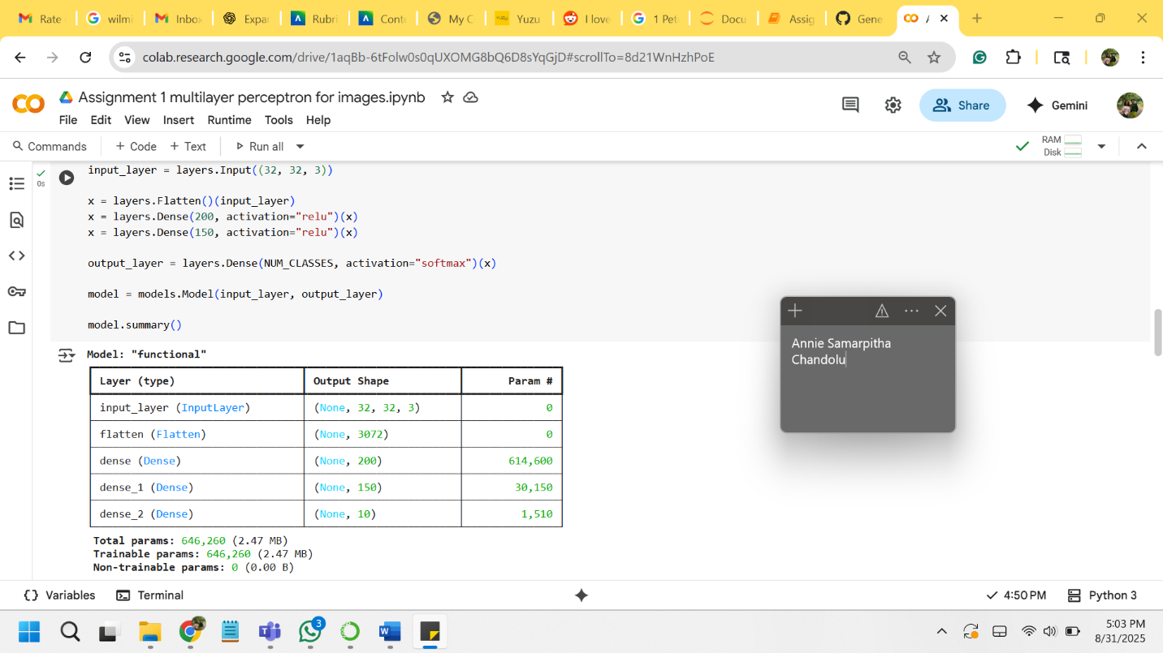
Figure 1. ReLU model implementation, accuracy: 0.4882 - loss: 1.4283.

Figure 2. Generated Images.
The ReLU-based MLP using the GitHub Code, achieved an accuracy of 0.4882 and a loss of 1.4283 on the test dataset while it resulted in an accuracy of 0.1120 and a loss of 0.9726 on the test dataset. While this performance is lower than expected for MNIST, it demonstrates how the choice of model architecture and hyperparameters can significantly impact results. ReLU still offers advantages due to its simplicity and ability to mitigate the vanishing gradient problem. Training was stable, though care must be taken to address potential issues like “dying neurons,” where units output only zero (Foster, 2022).

LeakyReLU
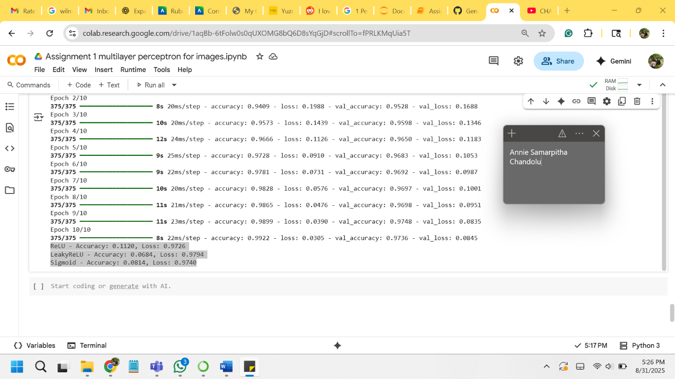
Figure 3. ReLU, LeakyReLU, Sigmoid implementation.
The LeakyReLU-based MLP achieved an accuracy of 0.0684 and a loss of 0.9794. This activation function allows a small gradient for negative inputs, reducing the likelihood of inactive neurons compared to standard ReLU. Although the model was stable during training, the low accuracy indicates that further tuning of the network or preprocessing is needed. LeakyReLU provides more robust neuron activation, but in this case, it did not translate to higher accuracy (Foster, 2022).

Sigmoid
The Sigmoid-based MLP achieved an accuracy of 0.0814 and a loss of 0.9740 on the test dataset. Sigmoid functions are prone to the vanishing gradient problem, which slows convergence and limits the network’s ability to learn deep representations. The low accuracy in this experiment confirms that sigmoid is less effective than ReLU or LeakyReLU for hidden layers in modern deep networks (Foster, 2022).

Conclusion
The results indicate that ReLU and LeakyReLU are generally preferred activation functions for image-based MLPs, but in this experiment, all models produced lower-than-expected accuracies. Using the provided code facilitated model building and training, and the results highlight the importance of proper hyperparameter tuning and preprocessing. ReLU remains a simple and effective choice, while LeakyReLU can provide additional stability, and Sigmoid is generally less suitable for hidden layers.

References
Foster, D. (2022). Generative deep learning (2nd ed.). O’Reilly Media. https://reader2.yuzu.com/reader/books/9781098134143/epubcfi/6/2[%3Bvnd.vst.idref%3Dcover]!/4/2/2%4054:75
Foster, D. (2022). Code for multilayer perceptron assignment. GitHub. https://github.com/davidADSP/Generative_Deep_Learning_2nd_Edition/blob/main/notebooks/02_deeplearning/01_mlp/mlp.ipynb?short_path=565a3ab

